HD 217107

HD 217107 is a 1.09 M☉, G8 IV1. The CH survey reported a Hot Jupiter (HD 217107b) signal with a period of 7.12 days, a minimum mass of 1.4 MJup and an eccentricity of 0.12 as well as a LPGP (HD 217107c) signal with a period of 4270 days, a minimum mass of 2.62 MJup and an eccentricity of 0.51. Based on 138 RV HIRES measurements obtained between 1998 and 2019, 207 RV Apf measurements obtained between 2013 and 2019 and 132 RV ELODIE measurements obtained between 1998 and 2008, the CL survey reported properties of HD 217107b close to those of the CH survey and a period of days, a minimum mass of 4.31 ± 0.13 MJup and an eccentricity of for HD 217107c.

In the present study, in addition to the CL survey’s dataset, 41 RV MINERVA data obtained between 2016 and 2018, 23 RV CES data obtained between 1999 and 2005 and 63 RV CORALIE data obtained between 1998 and 1999 were used. DPASS and MCMC (1000 walkers and 300000 iterations) were used to fit the data. To converge more easily, the priors on the semi-major axis of HD 217107b were close to the value found in the CL survey. The properties found for planets HD 217107 b and c reported in the CL survey were within the error bars associated with the values found in the present analysis.

The fits are shown in Fig 1, and the corner plot in Fig 2, and the results summarized in Table 1.

Conclusion: The properties of HD 217107c found in the CH survey are not confirmed but those found in the CL survey are confirmed.

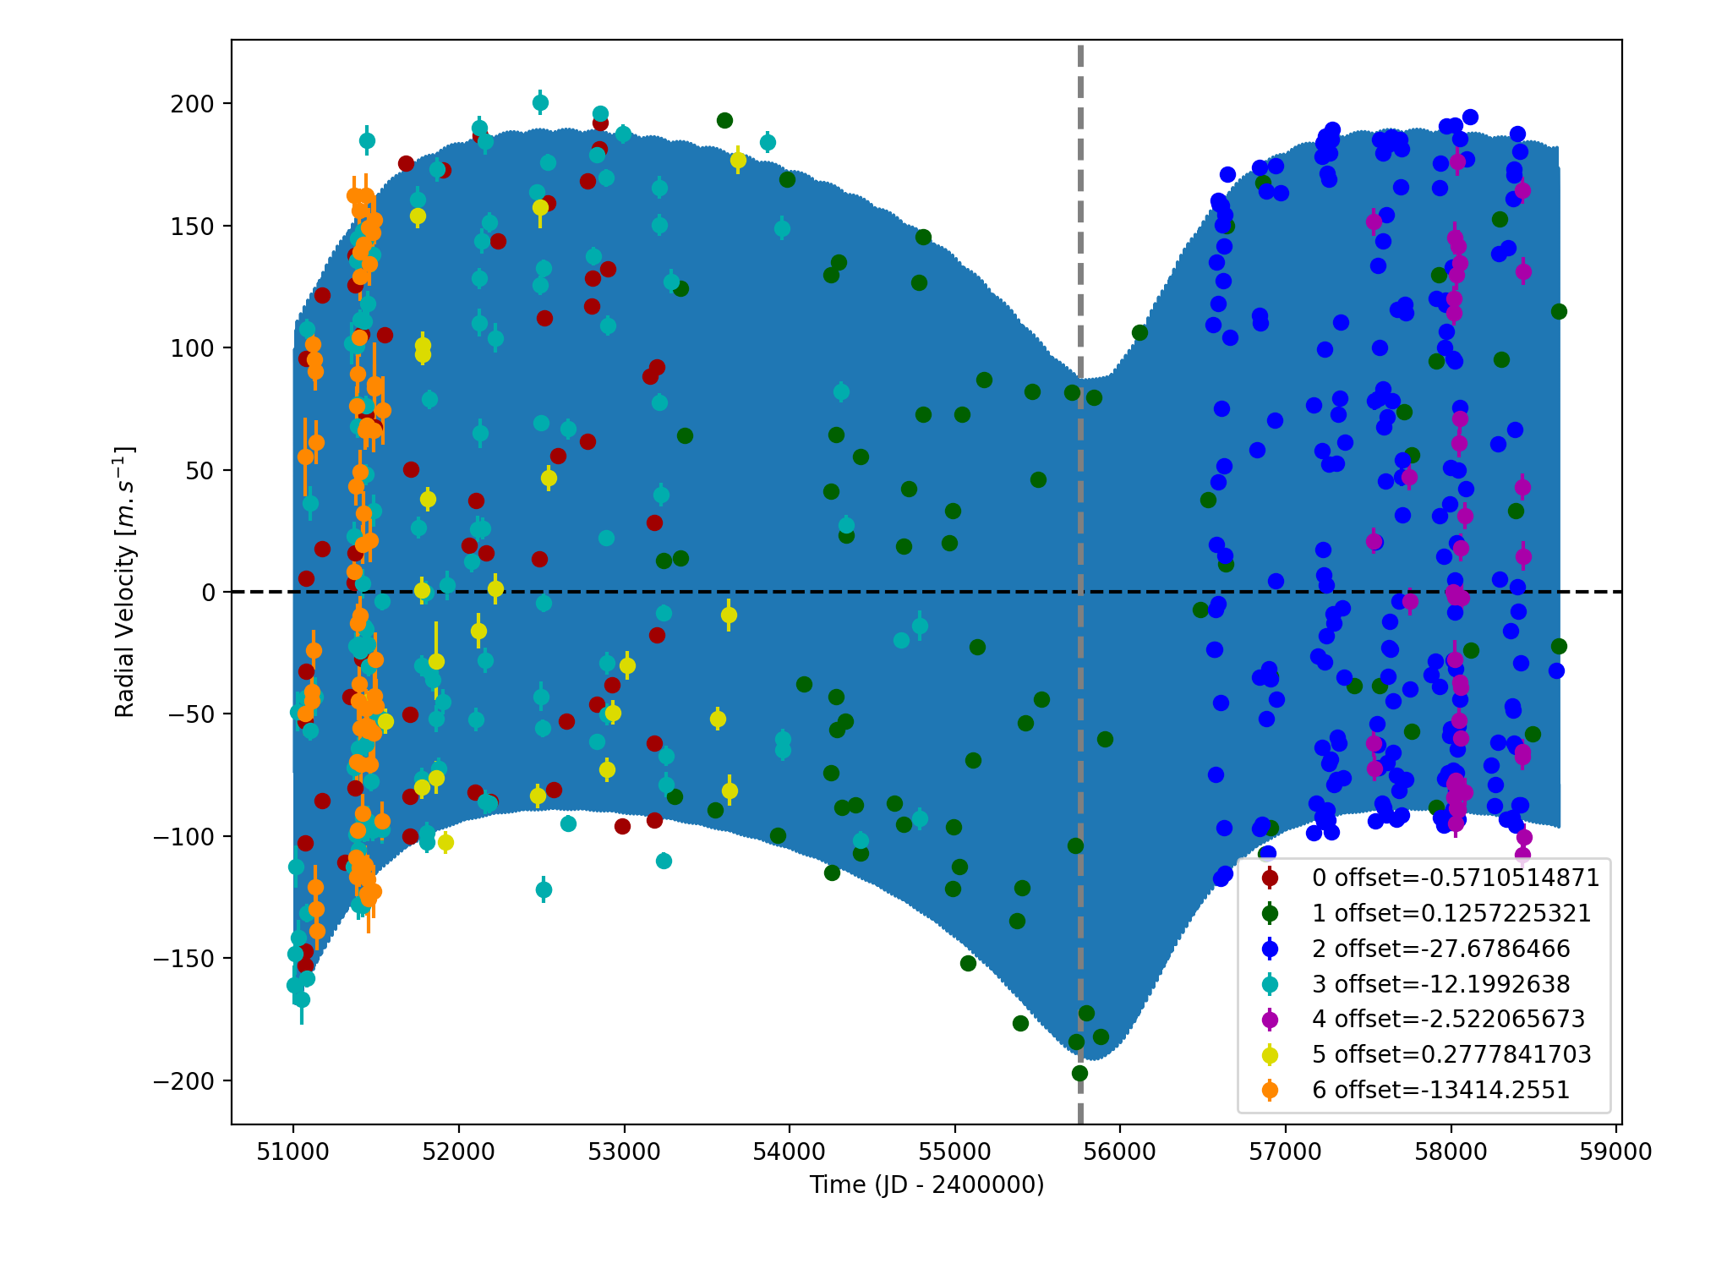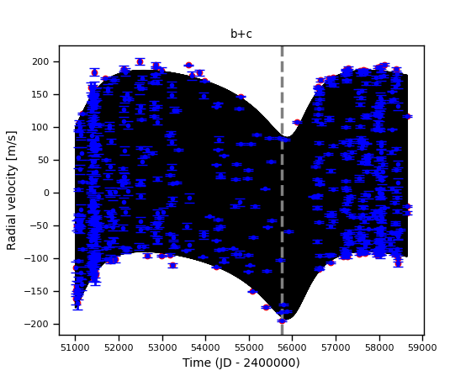

Figure 1: Left: fit of the HD 217107 RV with DPASS. Red - Hir94, green - Hir04, blue - Apf, cyan - LICK, purple - MINERVA, yellow - CES, orange - C98. The blue curve shows the best fit. Right: fit of the HD 217107 RV using MCMC. The black curves show the best fits. The gray dotted line indicates the end of the CH survey.

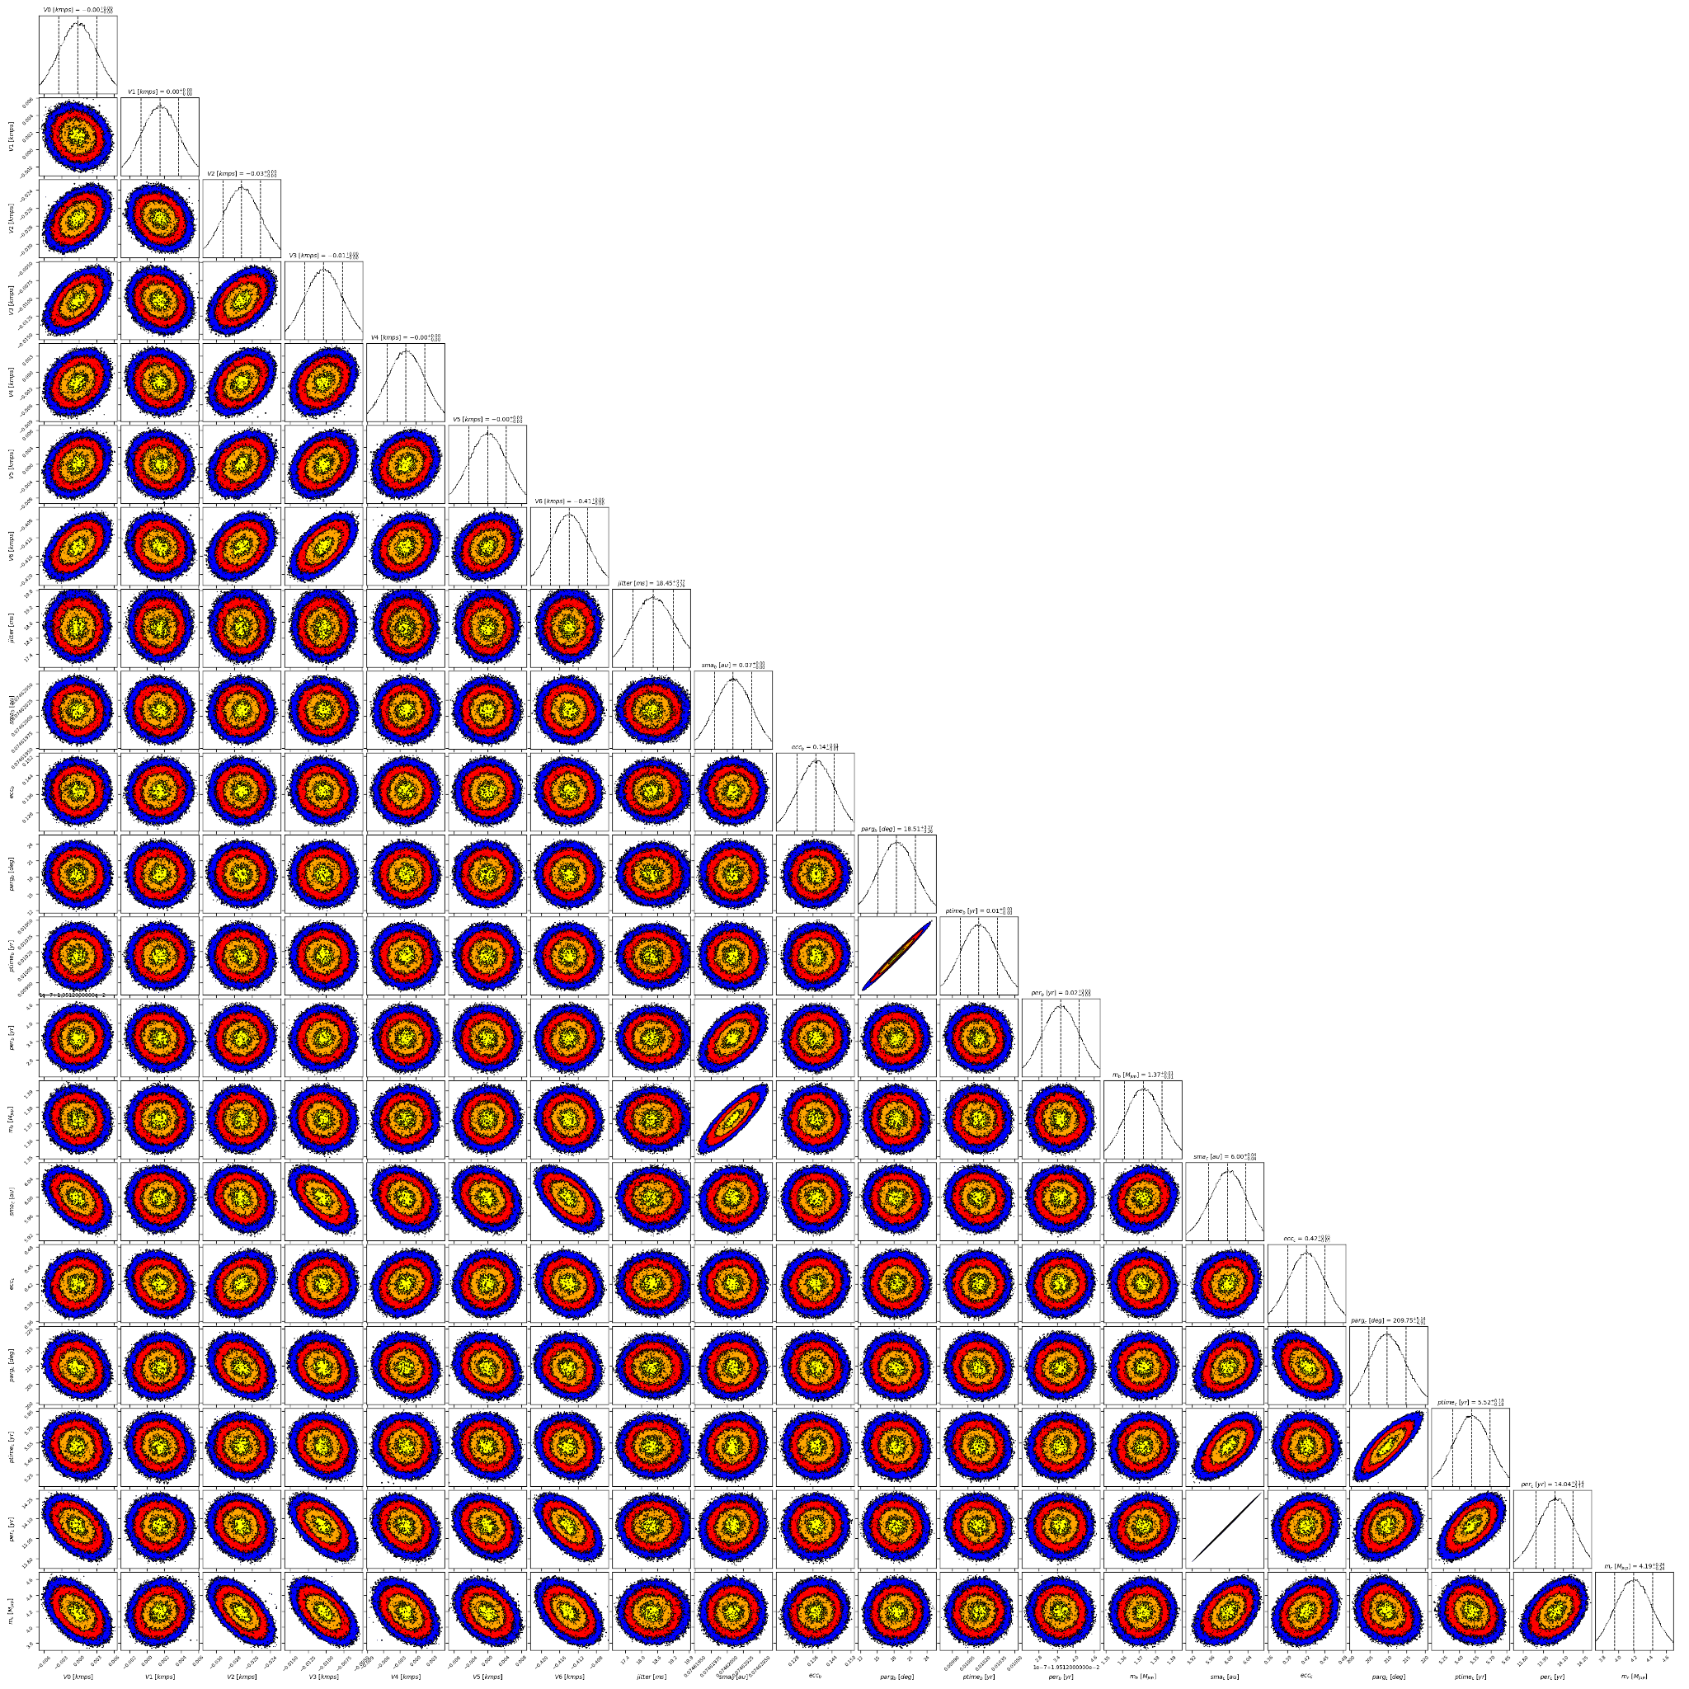

Figure 2: Corner plot of posteriors for the two-planets model MCMC fit of HD 217107 RV data.

| Parameter | Priors | | Posteriors | | CH/CL survey |
| --- | --- | --- | --- | --- | --- |
|  | DPASS | MCMC | DPASS | MCMC |  |
| *a* (au) | b: [0,100]  c: [0,100] | b: [0.07,0.08]  c: [1,65] | b = 0.073  c = 5.9 | b = 0.075 ± 0.001  c = 6.00 ± 0.04 | CH survey:  b = 0.07  c = 5.2  CL survey:  b =  c = |
| Msin(i) (MJup) | b: [0,100]  c: [0:100] | b: [1,2]  c: [1,10] | b = 1.3  c = 4 | b = 1.37 ± 0.01  c = 4.2 ± 0.2 | CH survey:  b = 1.4  c = 2.62  CL survey:  b = 1.385 ± 0.039  c = 4.31 ± 0.13 |
| Eccentricity | b: [0,0.95]  c: [0,0.95] | b: [0,0.2]  c: [0,0.9] | b = 0.13  c = 0.41 | b = 0.14 ± 0.01  c = 0.42 ± 0.03 | CH survey:  b = 0.12  c = 0.38  CL survey:  b =  c = 0.42 ± 0.02 |
| Instrumentals offsets (m/s) | [-60,60] | Hir94: [-1,1]  Hir04: [-1,1]  Apf: [-1,1]  LICK: [-1,1]  MINERVA: [-1,1]  CES: [-1,1]  C98: [-14,-12] | Hir94: -0.001  Hir04: 0.000  Apf: -0.028  LICK: -0.012  MINERVA: -0.003  CES: 0.000  C98: -13.414 | Hir94: -0.000 ± 0.003  Hir04: 0.002 ± 0.002  Apf: -0.027 ± 0.002  LICK: -0.010 ± 0.003  MINERVA: -0.0019 ± 0.0035  CES:  C98: -13.414 ± 0.001 |  |
| Stellar jitter (m/s) | [0,40] | [0,40] | 13.6 |  |  |
| Argument of periastron (°) | b: [0,360]  c: [0,360] | b: [0,360]  c: [0,360] | b = 360  c = 208 | b =  c = 210 ± 5 |  |
| Phase | b: [0,1]  c: [0,1] | b: [0,1]  c: [0,1] | b = 0.1  c = 0.9 | b = 0.52± 0.01  c = 0.39 ± 0.01 |  |

Table 1: HD 217107. Summary of priors and posteriors obtained with DPASS and MCMC compared to the results obtained by the CH and the CL surveys.

References

1. Giovinazzi, M. et al. The HD 217107 planetary system: Twenty years of radial velocity measurements. *Astronomische Nachrichten.* 341, 870-878 (2020).